

**LA GRANDEE INTERNATIONAL COLLEGE**

**Simalchaur, Pokhara Nepal**

Midterm Report On

**“Gym Management System”**

**Submitted to:**

Bachelor of Computer Application (BCA) Program

In partial fulfilment of the requirements for the degree of BCA under

Pokhara University

**Submitted by:**

|  |  |  |  |
| --- | --- | --- | --- |
| **Name:** | **Course** | **Semester** | **P.U. Registration Number** |
| Kailash Gurung | BCA | 4th | 2021-1-53-0352 |
| Krishna Bahadur Gurung | BCA | 4th | 2021-1-53-0353 |
| Prajal Gurung | BCA | 4th | 2021-1-53-0359 |

**Date: 10/01/2024**

**Table of Contents**

Table of Figures iv

Abbreviations v

1. Introduction 1

2. Problem Statement 2

3. Objectives 3

4. Background Study 4

5. Requirement Document 5

5.1 Functional requirements 5

5.2 Non-Functional Requirements 5

6. Methodology 6

5. System Diagram 8

5.1 Data Flow Diagram 8

5.1.1 Level -0 DFD 8

5.1.2 Level -1 DFD 9

5.1.3 Level -2 DFD of Login 10

5.1.4 Level -2 DFD of Registration 10

5.2 ER-Diagram 11

5.3 Database Diagram 13

6. Project Gantt chart 14

7. Deliverables 15

8. Conclusion 17

9. Reference 18

# Table of Figures

Figure 1.1: Waterfall Model 6

Figure 2.1: ER-Diagram of GMS 9

Figure 7.1 Database Diagram of GMS 10

Figure 8.1: Project Gantt Chart 11

Figure 9.1: Login Page 12

Figure 9.2: Registration Page 13

# Abbreviations

|  |  |
| --- | --- |
| MS- Word : | Microsoft Word |
| ER-Diagram : | Entity Relational Diagram |
| VB.NET : | Visual Basic Network Enabled Technologies |
| MS Office : | Microsoft Office |
| GMS : | Gym Management System |
| MySQL : | My Structured Query Language |
| RDBMS : | Relational Database Management System |

# Introduction

A management system is the framework an organization uses to oversee its operations, aiming to achieve its objectives. A Gym Management System is specialized software designed to assist fitness facility operators in efficiently managing and operating their gyms. It serves as a dedicated tool for managing and organizing gym-related information.

The primary goal of this project is to manage gym operations strategically and systematically, particularly regarding member data and equipment. Implementing this system can enhance inventory control, increase operational efficiency, streamline sales and monetary management, improve customer service, and enable data-driven decision-making.

The motivation behind creating a Gym Management System is to empower fitness facility operators with a comprehensive tool for managing and optimizing their gym business. It allows them to stay informed about equipment inventory, storage capacity, and cost management, minimizing the expenses associated with unsold resources. The system automates various aspects of gym management, including inventory, member transactions, customer interactions, and reporting. The overarching aim is to boost operational efficiency, enhance customer service, and enable more informed business choices. Additionally, it can help businesses save money by reducing the need for excessive or surplus equipment.

A Gym Management System is a software application that simplifies administrative tasks, aiding in transaction recording and member information management. It centralizes information for easy access and updates, including details such as member profiles, equipment data, and pricing. Additionally, it helps to track equipment for its maintenance.

Throughout the project, various software tools, including ER diagrams, were employed to support its development. The coding was conducted in the VB.NET language using "Visual Studio" software. The project tasks were evenly and equally distributed among team members according to their skills and knowledge.

# Problem Statement

Problem identification is the hardest part of developing a system. The broader the business goes the need for proper automated recordkeeping record-keeping felt. It is impossible to keep a complete detail on paperwork. Furthermore, it loads the data entry, does not provide easy access to the stored data and various other irrelevance.

Some Problems that we collected are as follows.

* Time consuming in recording keeping.
* Loss or damage of files and information.
* File consumes more space.
* Unable to track equipment.
* Staff management.

Common problems include data redundancies, paperwork, less flexible system, out-of-date systems, unorganized tasks, and storage issues.

# Objectives

The investment required for establishing a gym is enough to operate a large-scale business. GMS aims to increase efficiency, reduce costs, enhance member satisfaction, and stimulate revenue growth of the fitness center or Gym.

* Proper membership and inventory management by securing business records
* To optimum utilization of available resources.
* To facilitate special scheme.

# Background Study

We initiated our investigation by recognizing the necessity for a Gym Management System (GMS) within the organization. Initially, our research was focused on identifying the underlying reasons that necessitate the implementation of a GMS. We gathered various project requirements through preliminary research, website visits, and interviews with relevant personnel who shared their insights and experiences related to GMS development.

During our analysis, we found an application near our location, which was a Gym Management System implemented as a fully business purpose. The primary goal of the project was to create a system that could be easily managed and provide security while covering all the key aspects of GMS, such as member details, employee information, attendance tracking, and equipment management.

However, it became apparent that the project had limitations, primarily that it was not suitable for large-scale gym facilities. It featured a single admin panel and lacked the scalability required for organizations with a substantial volume of members and multiple gym branches. After a thorough evaluation of this project, we decided to enhance the capabilities of the GMS by designing a more interactive user interface and making the system adaptable to the needs of larger and more complex gym organizations.

# Requirement Document

Requirements document is the foundation of project that shows the project’s needs, expectation, functionality and non-functionality which should be addressed to achieve the project goals. The purpose of the project is to describe the different functional and non-functional requirement for GYM MANAGEMENT SYSTEM application based on vb.NET and MS-SQL Server. This document is used to identify the purpose of the project and helps in different phases of development while making application.

## **Functional requirements**

* Member Management: This includes registration to register new members, manage member to update, view and delete and to manage member plans i.e. renewal process or subscription.
* Trainer Management: Maintain and manage the trainer profile and schedule.
* Equipment Management: Track inventory equipment.
* Attendance Management: Record member attendance for in and out.
* Billing and Payment: Calculate the bills and payments.
* Reporting: Generate report of member and employee activities and track gym performance.

## **5.2 Non-Functional Requirements**

* Usability: The application must have a user-friendly interface with easy navigation.
* Performance**:** The application must meet certain performance requirements such as fast loading time and low memory usage.
* Security and privacy: The application must have security and privacy features which is authentication and authorization.
* **Compatibility**: Compatibility with various devices or platforms.

# Methodology

A methodology is a series of processes or phases, which helps you define which stage you are at the given period. A set of procedures or methods to develop software is known as software development methodology. Methodology shapes a structure of software thus it is important to precisely choose the required method to develop software. In Context of our project, we choose Waterfall Module to develop a project as it works well in small project. In this method, project activities are break into linear sequential phases, each phase depends upon the previous one.

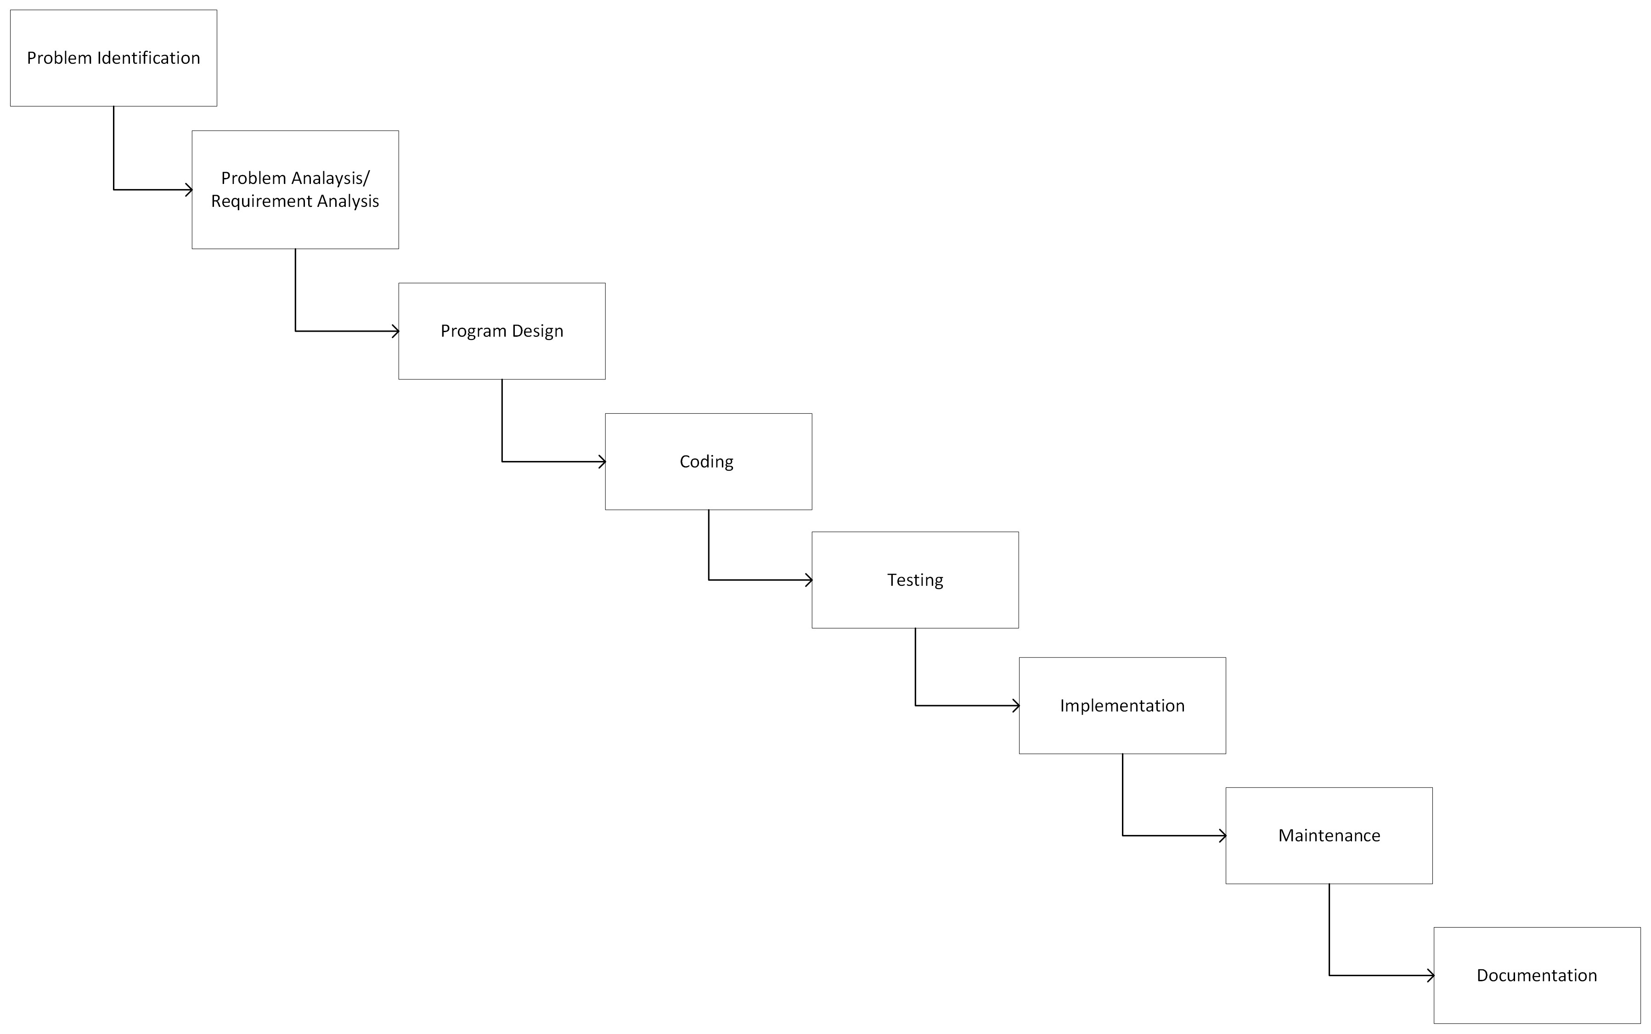

Figure 1.1: Waterfall Model

There are 6 major phases of SDLC −

1. Problem Identification
2. Problem Analysis / Requirement Analysis
3. Program Design
4. Coding
5. Testing
6. Implementation
7. Maintenance
8. Documentation

# System Diagram

Dataflow diagram, Database Diagram and ER diagram are used for understanding the system’s design and its functionalities, and both are important for creating proper documentation

We represent the design of our system by using DFD, Database Diagram and ER Diagram.

## **5.1 Data Flow Diagram**

DFD stands for Data Flow Diagram. A Data Flow Diagram is a graphical description of how data flows through a system. DFD is a technique that shows how data flows through a system, what transformations are applied to the data, what files are utilized, and where the program’s outputs flow. It’s a process oriented graphical tool for representing an organization’s business with information on processes, data storage, data flow and external entities.

The DFD of our system is given below:

## **5.1.1 Level -0 DFD**

Indexes:

(1) External Entities

* Admin
* Customer

(2) Customer_info

* Customer’s Name and Id
* Order Id

(3) Database

* Customer_info
* Equipment_info
* Login_info

(4) Login_info

* Username
* Password

17

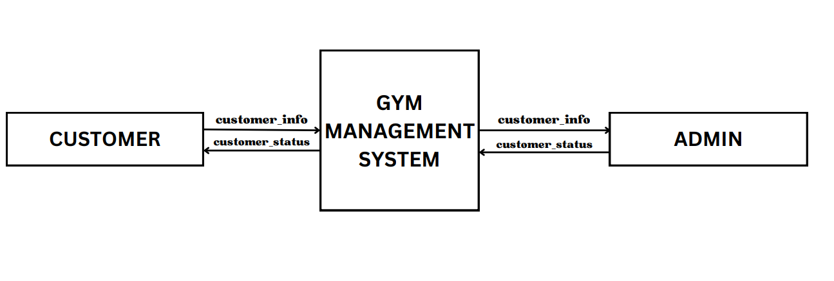

Figure 5.1.1: level 0 DFD

## **5.1.2 Level -1 DFD**

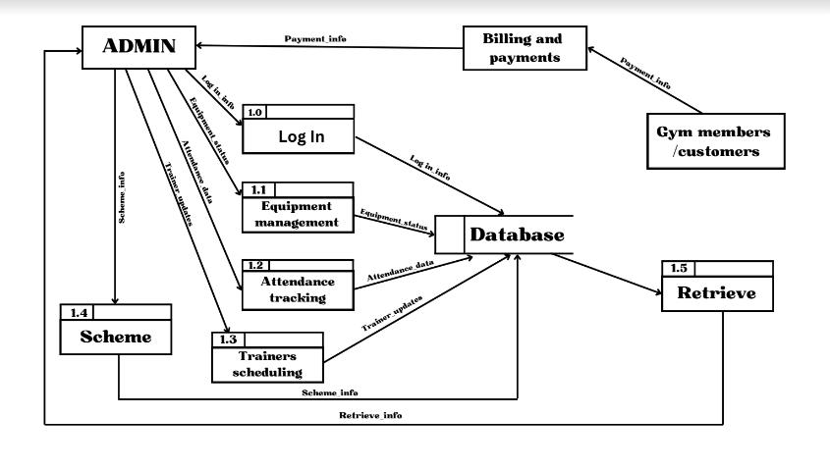

Figure 5..2: Level 1 DFD

## **5.1.3 Level -2 DFD of Login**

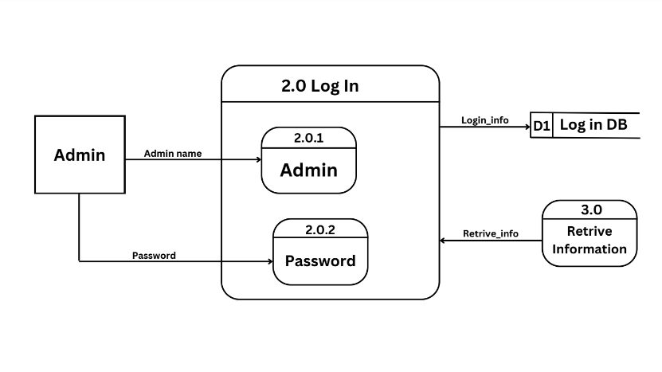

Figure 5.1.3: Level 2 DFD of Login

## **5.1.4 Level -2 DFD of Registration**

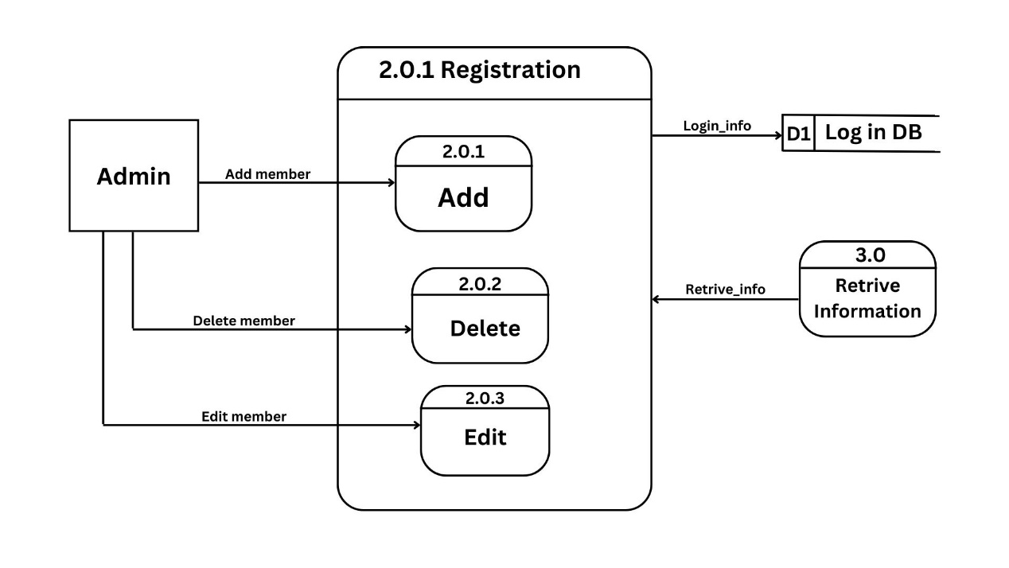

Figure 5.1.4: Level 2 DFD of registration

## **5.2 ER-Diagram**

Entity:

* User
* Member
* Receptionist
* Trainer
* Equipment
* Attendance

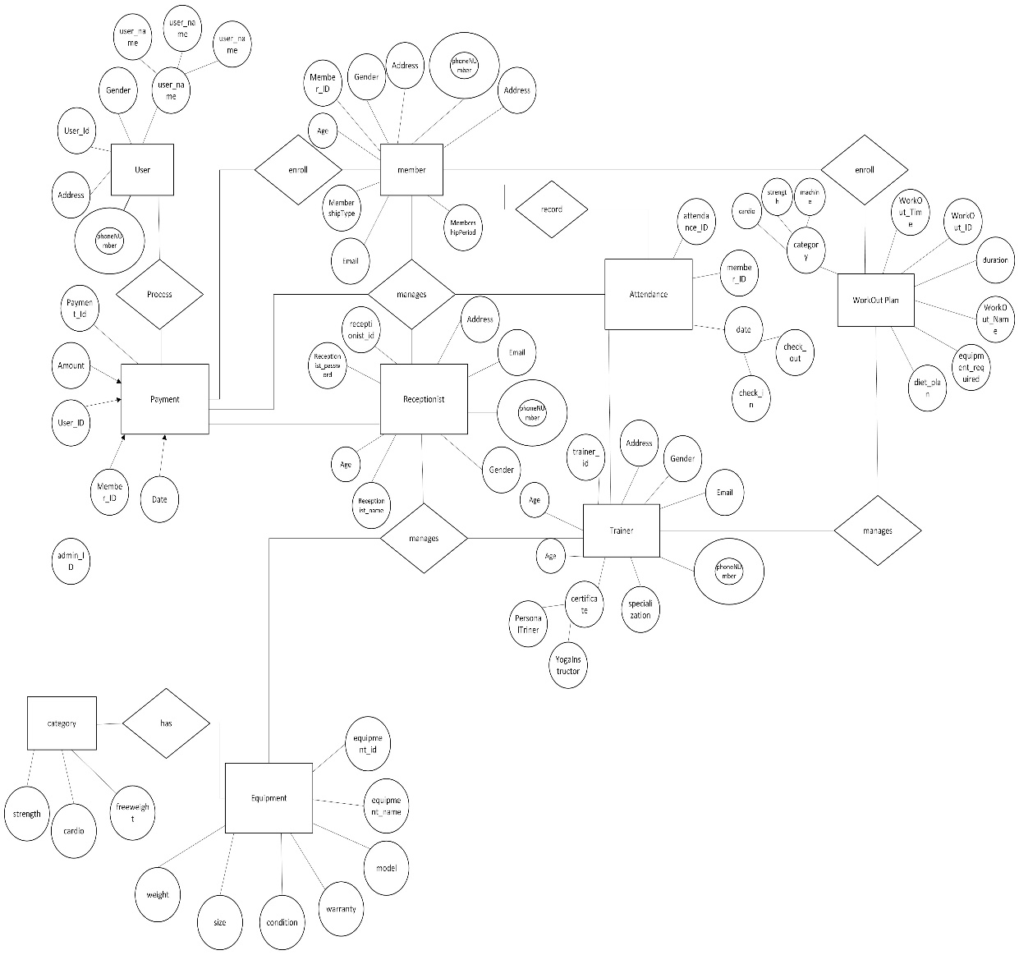

Figure 2.1: ER-Diagram of GMS

## **5.3 Database Diagram**

# 

Figure 7.1 Database Diagram of GMS

# Project Gantt chart

A Gantt chart is a popular project management tool used to visualize the schedule of a project. It displays tasks or activities against time, allowing project managers to track progress, manage dependencies, and allocate resources efficiently.

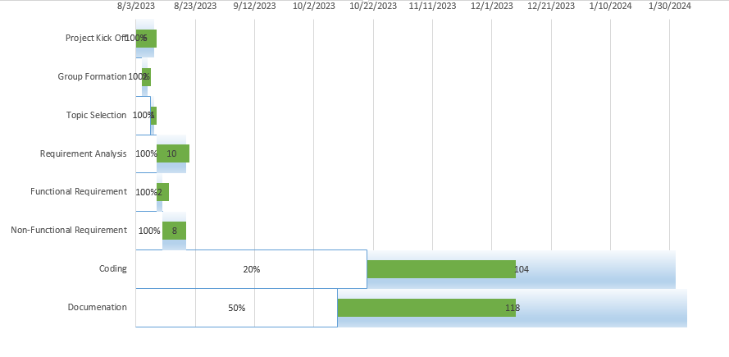

Figure 8.1: Project Gantt Chart

# Deliverables

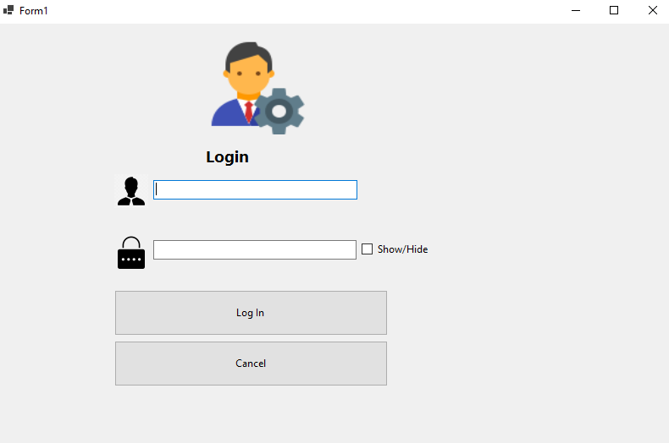

Figure 9.1: Login Page

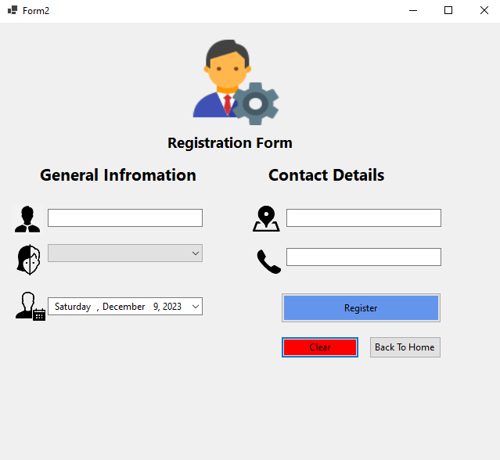

Figure 9.2: Registration Page

# Conclusion

In conclusion, our Gym Management System (GMS) is designed to assist gym owners in efficiently monitoring and handling their facility's operations, encompassing member management, inventory control, and sales tracking. The primary objective is to enhance workforce productivity, maintain operational efficiency, and minimize operational costs within the gym setting. Our comprehensive report outlines the various components of our GMS.

We will develop our system using the VB.NET programming in the Visual Programming software environment. Additionally, we have employed visual aids such as the Waterfall Software Development Model, ER-Diagram and Gantt charts to illustrate the project's progress and techniques.

Consequently, our GMS aims to deliver an error-free, secure, reliable, and efficient management system tailored to the specific needs of gym operations. This system will relieve gym staff from burdensome record-keeping tasks, allowing them to focus on other essential activities. As a result, gym owners and administrators will find the system user-friendly and supportive in streamlining their tasks. Moreover, our GMS will diligently manage and document every transaction that occurs within the gym, ensuring a thorough and organized record of operations.

# Reference

**Sulav Thakuri,City Gym Pokhara**

https://vymaps.com/NP/City-GYM-Health-Fitness-Center-Pvt-Ltd-113114673407210